OLORUNJUWON OLUTOKI

CS465 MODULE ONE ASSIGNMENT

Introduction to HTML

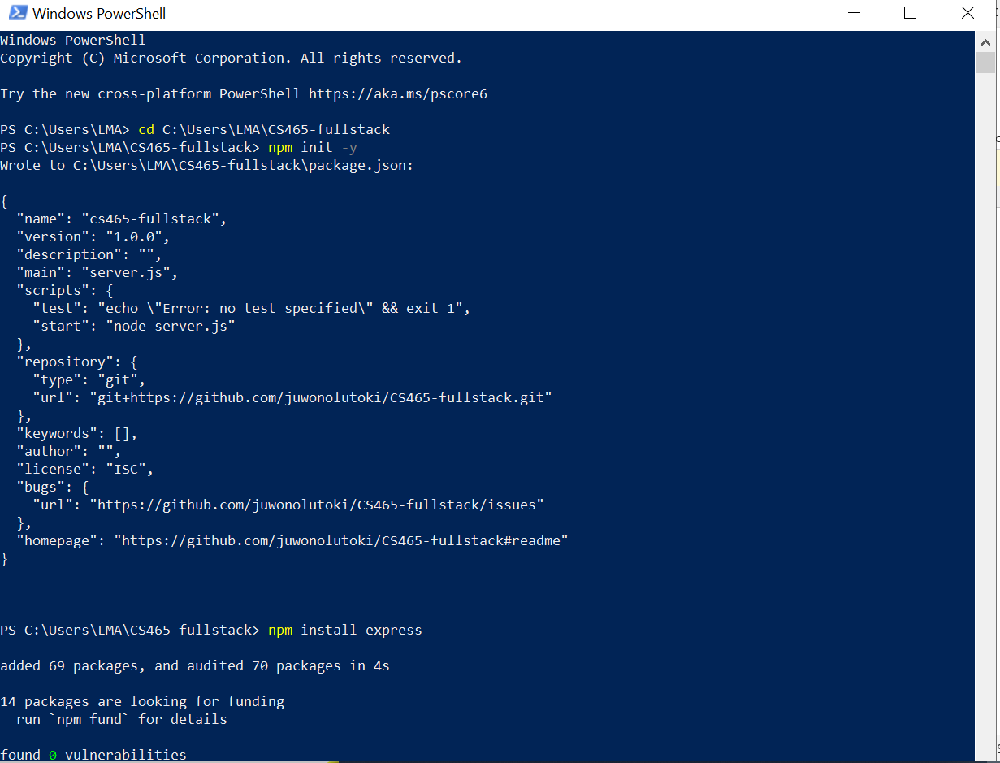

When I tried to zip the whole package together, I got an error saying “routes” folder could not be included it was empty, I just wanted to put that here.

